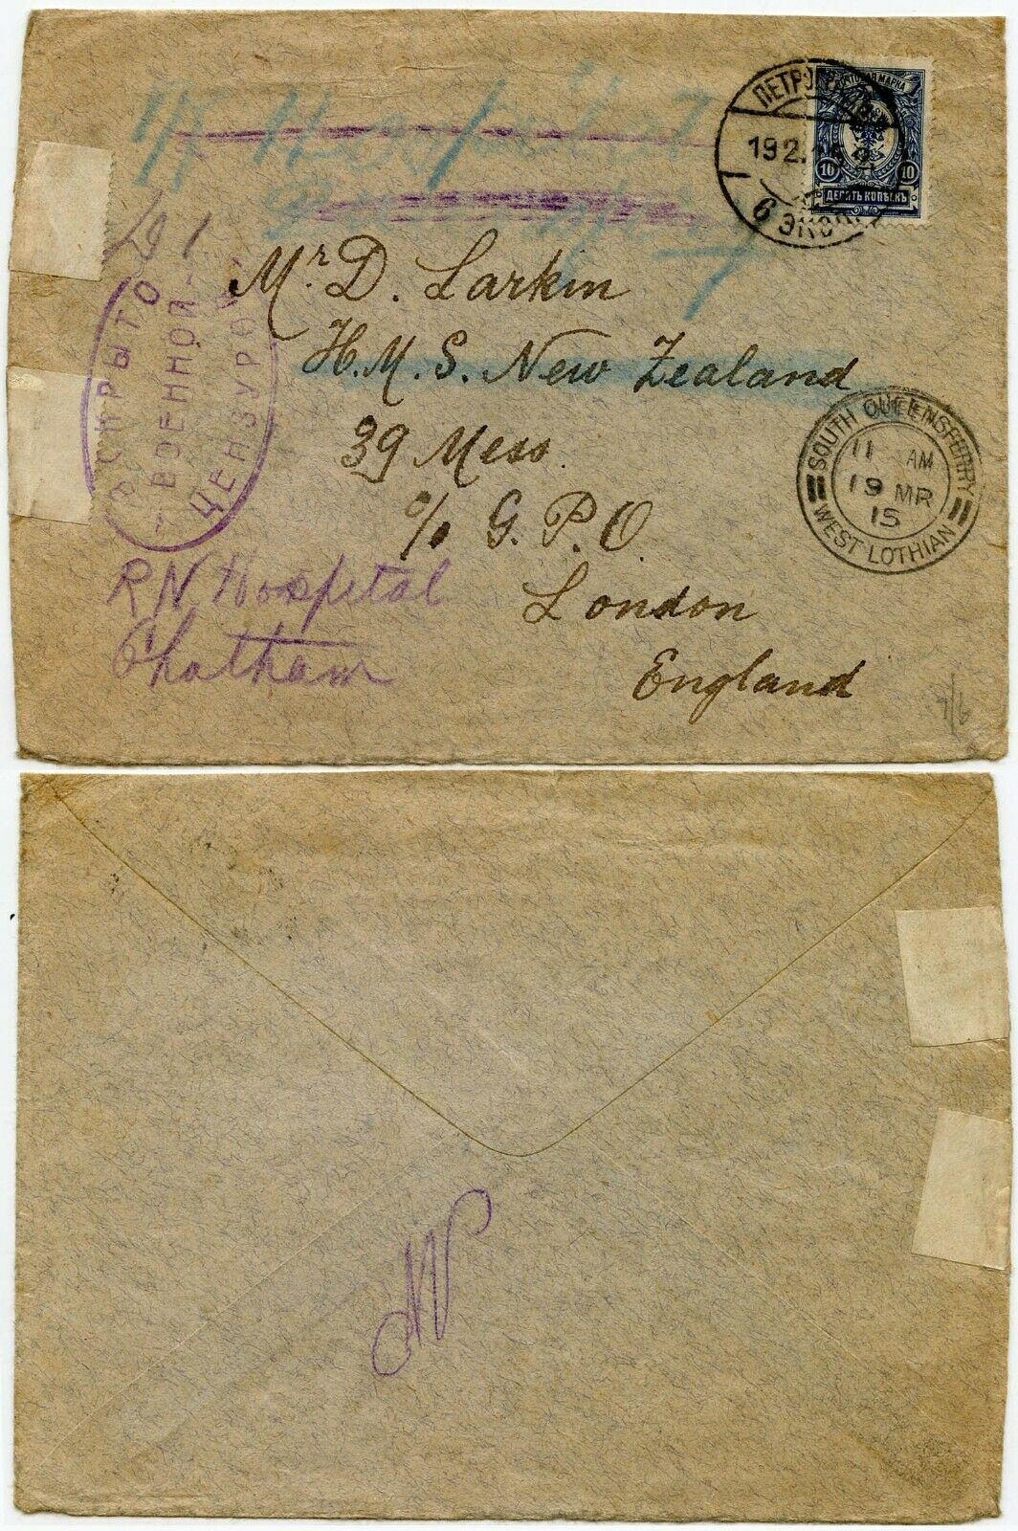
RUSSIA to GB HMS NEW ZEALAND 1915 WW1 NAVAL HOSPITAL CHATHAM + SOUTH QUEENSFERRY
Envelope to Larkin on H.M.S New Zealand c/o G.P.O London; redirected to Royal Naval Hospital Chatham; 10k single franking; Russian cancel + South Queensferry West Lothian postmark.

