SHEWING THE FLAG……………………………………….
THE CRUISE OF H.M.S. “LYCHNIS”…………………..

9th July 1919 to 28th July 1919

W.G.J. STEVENS.

8TH July 1919.
Sailed from SALONIKA at 0930 – an exceedingly hot day.
It was arranged for my old Writer (Able Seaman Bernard J. Roche) to remain at SALONIKA to enable me to take this trip. This morning, however he was sent to hospital with Malaria and so the question arose as to me being spared from Salonica for a period of three weeks when no officer or man was left behind who was fully conversant with the S.N.O.’s department
N.T.O.’s Secretary was exceedingly good in agreeing to carry on without Roche and with the N.T.O.’s concurrence at 0830 I went ashore picked up the Naval car, raced over to the office on the English Quay, turned over my keys to N.T.O.’s Secretary and with my new writer raced back to the staff residence collected gear and reached the White Tower Pier again at 0855, I having travelled about five miles by car and boat in the 25 minutes besides transacting various jobs of work which included completing packing of gear.
H.M.S. “LYCHNIS” proceeded at an easy speed down the Gulf of SALONIKA and then turned eastward and steamed along towards Mount Athos Peninsular in the setting sun which was slowly disappearing a flaming ball of fire, behind the hills of the mainland of Greece.
The Kassandra Peninsular at its foot is fairly thickly wooded but there are no apparent signs of cultivation which probably is carried out near the villages hidden by hills from seaward.
In the distance the Pallene Peninsular loomed up in the gathering greyness of evening with Mount Athos, on the third peninsular of the Chalcidique showing up in the far distance over the rising ground and hills of the Pallene Peninsular
It was a glorious evening with a slight following breeze – the only noise was made by the small crested wavelets thrown back from the ship’s side, as she forged ahead, to meet the larger ocean beyond.
These quiet evening hours, the expanse of water all round, the high austere hills in the distance, made a vast contrast to the noise and bustle of life even in such a town as Salonika where everyone is out to get the most enjoyment out of life under the most sordid surroundings.
The ship was followed out from Salonika by a small Greek steamer which overtook us when lying stopped at the entrance to the Gulf of Salonika to permit the ship’s company to bathe. This small coaster was evidently steaming about half a knot faster than us. Once underway again we slowly caught her up and at 1800 were just abreast. Later she suddenly altered course to seaward and crossed our bows so close that a collision was only just avoided by putting the ship’s engines hard astern. The reason for this sudden alteration of course was not apparent except that she was probably too close to the land.
9th July 1919.
STAVROS – arrived 0530 – a very breezy day. The ‘beach’ looks particularly inviting – small white houses dotted about amongst the trees with a small village inland on the slope of a hill.
Alongside the wooden pier were two Greek Steamships, so it was thought, but the eventually proved to be the Mudros Water Boat “WATCHER” and the Greek steamship “ARGOLIS” the latter loading ammunition under charge of the Greek Military authorities.
“WATCHER” sailed at 0930 without reporting in any way to LYCHNIS and thus an opportunity of dispatching a mail to Mudros and England was missed.
Landed about 0900 and we were informed by a Greek Corporal in the village that there were about 1500 Greek troops present, but it was thought he meant on the whole of the Decauville system to Sarakli from Stavros which is now worked by the Greek Army. (Note, a Light Railway System)
There was a considerable amount of ammunition awaiting shipment, but the rate of loading was truly oriental.
EGGS are 4d Each and the boy who sold them to us stated the Greek soldiers pay the same price for this commodity.
In the afternoon a trip to the Village of VRASTA, which is hidden behind the spur of a hill about six miles inland to the northward.
The walk to this village is partly through sandy plain with heavy undergrowth and wild flowers. The scent of the flowers was very strong and in some places where the sun beats down with extraordinary strength, the scent was almost overpowering.
VRASTA lies about N.N.E. from Stavros Village and after traversing three miles of plain the ascent to the village was commenced, The track is not at all clearly defined and in places it crosses a dry river bed where it is lost in the stony and sandy bed itself.
We finally lost the track and made for the village up the river bed over boulders of varying sizes – this was a steep ascent made more difficult by the uneven ground.
The Village of VRASTA was finally reached and Turkish Coffee obtained – several of the children speak English, the last reminder that the British lived in the vicinity for three years.
At this village EGGS were our aim and object and after much bargaining six were obtained from a loafer at the Café for Drachmas 1.80. Later we obtained nine more eggs for Drachmas 2.50.
One boy – who acted as Interpreter for the second purchase of eggs – told us that if we gave then JAM we would get a quantity of eggs. He added that since the English had left the vicinity there was no more jam to be had.
On the return from our Egg Purchasing Expedition a street photographer prevailed on us to have a photo taken – so the three of us (Commander Noakes, Sub Lieut. Smith and self) posed and after much delay the photo was taken. The result was really very remarkable for the primitive photographic set this would-be-Downey was possessed of.
The return journey was commenced about 1500 and was at a very slow pace to enable the precious eggs to reach the ship without mishap.
Numerous butterflies were successfully entrapped both on the outward and return journey and safely deposited in the S.N.O.’s Killing bottle.
STAVROS was reached at 1700 and after one batch of liberty men had been dispatched to the ship we returned on board feeling very tired after a long day in the sun.
It is very marked how keen the travelling peasants were to say good-day to one – this is probably on account of their mercenary hopes that troops may return with the consequent ample supplies of food thrown away or bartered for local produce.
11th July 1919.
STAVROS. All around the vegetation is very luxuriant and this is a welcome change after the country immediately surrounding the bay of Salonika.
12th July 1919.
Sailed from STAVROS at 0330 – a calm sea and strong sun. “ARGOLIS” still loading ammunition on our departure. (Note, possibly in support of the Greek Army in Smyrna and Anatolia)
All day on the 11th July I was on board helping the Accountant Officer to get his ledgers up to date – we put in a hard day’s work, only completing same at 1700.
KAVALA. Arrived 0930. As one approaches this town from seaward it gives promise of being a clean and delightful place = white plastered houses built on the slopes of the hills which reach down to the water’s edge. The town is built round two small bays divided by a promontory on which is a small fortress and the remains of the old town walls and fortifications of which a considerable part still remains. From the fortress to the end of the promontory the older houses of the town stand.
The fortress is in a very bad state of repair with one large circular tower in the centre and flanked by a few small irregular bastions – the scheme for defence not being at all clearly defined. But for the old fortifications, which add a touch of romance to the town, it might otherwise have first been built in the middle of the 19th Century.
To the east and west of the promontory are modern houses, probably built within the last fifty years. The streets are dirty, badly paved with cobbles and generally similar to the other towns in Macedonia.
Close to the sea one is reminded of a fishing village on account of the heavy smell of fish or seaweed, probably the latter as no fish was obtainable.
EGGS were 6d each and very poor quality at that.
There is an excellently clean barber’s shop next to the biggest Café (the Pantheon) on the sea-front in the western part of the town. The cleanest and best equipped barbers ever met with in Macedonia.
The population is apparently largely Turkish. The Mosque of the Sultan ALI MAHOMED covers a considerable space in the old quarter of the town, with its innumerable low beaten lead cupolas. This Mosque was found fast closed and it was only after a certain amount of pressing and the promise of ‘backseesh’ that we gained admittance to the grounds.
A number of HADJI live in this Mosque’s precincts and in addition there is a school for Turkish children which we inspected.
A Hadji took us over the premises and showed a large dug-out, made by the Bulgars during their occupation of the town, in the garden of the place with strong steel girders for roofing. There was also a huge baking establishment where bread for the Bulgar troops was made and in addition a large underground room where stood two huge copper receptacles for cooking food and boiling water. The Mosque living quarters were undoubtedly used as a headquarters for the enemy troops.
Both the Mosques in this block of buildings were very plainly furnished – one had only rush mats on the floor but the other had some old carpets but none of them very fine in texture or design.
Keys were very frequently used inside the main door of the buildings – everything appeared to be closely locked up and carefully guarded.
We were invited into a sort of reception room where sitting on a Divan we inscribed our names in the visitors book which included the names of several Bulgarian and Hun officers. On leaving we were presented with the usual rose and passed over a goodly tip to the Hadji which he gravely accepted.
The Khedikal Palace Hotel on the sea-front was closed and in a bad state of repair due probably to the cessation of the Khedivial Line to run to Kavala during the period of the war.
The offices and workshops of the Turkish REGIE Tobacco Company are empty and had evidently been used by the Bulgars to quarter troops in – they are filthy.
The town generally is dirty and uninteresting, with the exception of the fortifications, the Mosque and the old Roman Aqueduct which is built on the isthmus joining the promontory to the east and west sides of the town. This aqueduct is of the usual Roman design and was apparently built to convey water from the hills to the fortress where it disappears in the ramparts of the fort.
13th July 1919.
The Collector of Customs called in the forenoon and informed S.N.O. that the Captain of the Port was absent sick and that he was carrying out both duties in the meantime. Information obtained from this official was:-
Governor of Kavala – M. Zaferopoules who is responsible to the Governor General of Eastern Macedonia at Drama.
Collector of Customs – M. Loverios.
3,000 houses damaged by Bulgars during their occupation of town.
18,000 persons (inhabitants of town) died of starvation during Bulgarian occupation of town.
Lighthouse destroyed by Bulgars.
Greek T.B.’s VELOS and NRA GENEA sunk 6 drifting mines off Kavalla four days since and found 8 moored mines at Porto Lagos about half a mile from the anchorage.
VELOS sighted one mine (light bar on top) off Mount Athos about five days ago.
The part of the town built on the eastern bay had been badly damaged by shell fire which an inhabitant stated was caused by British bombardment.
HONESTY. Having purchased lemons and paid for them, pears were also purchased and the vendor then stated he had not been paid for the lemons. After much argument we agreed to pay again and did so. Shoving off from the pier about 10 minutes’ walk from the pear vendor’s establishment his assistant rushed down to the boat and tendered 2 Drachmas which he stated had been paid but dropped in the street and not noticed by the old man. A remarkable case of honesty increased all the more than the assistant refused a tip for returning the overpayment.
In the evening at 1700 the Governor called with his wife and were shown over the ship. The return call was made at 1900 at the Greek Club which is accommodated in large rooms over the Bank of Athens and Panthoon Café.
These official calls are rather a joke – the Governor and his wife both speak a little French and so do we – but it is a little and hence the art of speaking by means of signs becomes a habit.

14th July 1919.
Sailed from KAVALLA at 0300 and reached Panaghia Roads, Island of THASSOS, at 0600 after carrying out one inch aiming practice at drifting target with the starboard 12 pdr and 4 inch guns, all ship’s guns’ crews being used and all gunlayers firing.
The village off which we anchored was LIMENA and immediately on anchoring a Greek seaman boarded the ship to ascertain details of ship, reason for visiting port etc.
There were only ciaques anchored here and very small ones at that with the exception of one large motor caique which left just after we anchored.
The village of LIMENA is small and typically Greek – no outstanding features whatever. The surrounding country is very fertile – trees in abundance particularly Olive.
THASSOS has a Governor and a Captain of the Port – the latter had left the day previous for Kavala.
The sea in the vicinity of this Island is delightfully clear and the bottom at 7 to 10 fathoms clearly discernible.
15th July 1919.
Sailed 0300 for KARA AGATCH which was reached at 0600 – owing to shoal water ship was anchored about four miles from the village.
From the sea the village or Town of Porto Lagos (or Kara agatch) appeared to be composed of about a dozen or so houses standing at the head of a large bay whose shores are very low lying. This low lying land stretches back in a flat plain for miles to the foot of a high range of hills.
We visited the town at 0830 in the ship’s skiff it was along hard pull for the boat’s crew requiring one spell of rest. We endeavoured to make the town in a straight line from the ship, but grounding in very shallow water about a mile from the town it was necessary to pull back some distance and enter a badly buoyed channel where there was plenty of water right up to the quay side.
The village is composed of about two dozen houses everyone being quite inhabitable through shell fire or bombs fired by the Allied fleets. It was a scene of utter desolation and most pitiable to look at.
We were met on landing by a Bulgarian Military officer, several soldiers and one sailor. The Officer informed us that he was Captain of the Port and requested the name of the ship, her commander and her reason if any for visiting the port.
This officer was strictly courteous but considerable difficulty was experienced in conversing with him as he knew practically no French and none of his men could speak any language we understood, save one civilian who spoke about a dozen words of English.
We asked for details of the mines laid in the vicinity and this information was not available but the officer phoned to DEDE AGATCH and promised to supply the required details in the afternoon.
The whole place is very deserted and but for a score or so of horses there was no sign of animal life, though it is thought there must be cattle further round the bay.
We were informed there were about 150 French troops at Xanthi about 25 Kilometres to the westward.
During the forenoon a mutilated message was received from the Captain of the Naval Base at Mudros stating that Kara Agatch should not be visited and that a Trawler would escort LYCHNIS to DEDE AGATCH and as the waters in which the ship was lying were not considered to be safe we sailed for THASSOS again at 1500, and arrived there at 1730.
On arrival there we received a correction to the original relevant message which stated that ship was not to move from her anchorage billet at Karaagatch and that a pulling boat was to meet a Drifter at a certain position the following morning when ship would be led out from the minefield in which she was anchored.
Mudros was informed of ship’s safe return to THASSOS and by return was ordered to MUDROS forthwith.
It transpired that although we had received orders to visit Kara-agatch, this port was not safe as the mine clearance had not been completed and the ship was actually in the centre of a very uncertain minefield but had luckily managed to hit off the swept channel into the place and following the same course in departing reached safe waters successfully.
Mudros had arranged wonderful preparation for extracting the ship from the minefield and had appointed the most expert mine-clearance officer in the Mediterranean to take passage in the drifter and bring us to safety. This however, was not necessary as we had reached Thassos again before realising the dangerous position in which we were.
16th July 1919.
Sailed for MUDROS at 0300 – a fine day – ship rolled considerably for the slight swell.
Arrived MUDROS 1230 – anchored close to H.M.S. “EUROPA” and S.N.O. reported to C.O.B. at 1430 for instructions as to minefield off Dede agatch and swept channel.
Sailed from MUDROS 2000 and reached Dede agatch following day.
On the evening of the 16th July I dined on board “EUROPA” with Bridgemore Brown (Secty to C.O.B. and late P.O. in London Division RNVR). Met Aldridge and Kersley (Pay. Lieuts RNR) both of whom served with me in EUROPA in 1915 but unlike me both have had one leave since then.

17th July 1919.
Two Drifters and one Motor Launch were in the roadstead on our arrival off Dede agatch at 0600 and all three vessels left during the forenoon for shelter as bad weather was expected and the anchorage is not sheltered in any way.
We landed at 0800 and called on the French Commander at his headquarters – he was away but we were received by the senior officer present – a captain – who very kindly invited us to lunch or dinner, both of which we were forced to refuse.
The town itself has been much damaged by allied shell fire, but there are many undamaged houses and quite a number of shops and cafes open and doing a fair trade.
Through the centre of the town, parallel with the quay, runs a wide street, well laid out with a wide road for vehicles down the middle and trees planted at the road’s edge, the pavements which stretch from the road side to the houses have a further row of trees planted down their centre. One is reminded of the Mall.
The Bulgarian Soldiers appeared to be very sullen and the higher grades continue to wear huge swords which emphasise the shabbiness of their uniforms.
According to the rate of exchange obtained in one of the smaller shops it appears that 5 Bulgarian francs were the value on 1½ French francs.
In the afternoon the men were allowed ashore but it commenced to blow hard at 1300 and it was decided to sail for Mudros if the weather did not soon improve. A big sea got up about 1500 and as soon as the liberty men had been embarked we weighed our anchor and got out of it. There was considerable difficulty in embarking the liberty men as such ships are only provided with small boats and the boat’s crew had a hard time pulling to and from the shore which was about 1 ½ miles distant. The majority of the men were thoroughly wet through on arrival on board.
A Greek caique bound for Kavala had anchored close to us during the day and about 1400 hoisted the Greek flag half mast and knotted. The Pilot went off to her and eventually after much palaver we agreed to tow her clear of the lee-shore, which necessitated the ship not steaming faster that 5 knots and even then the caique took in many green seas and looked often like disappearing down the next wave.
Slipped Caique at 2100 and proceeded at 10 knots to MUDROS. The crew of the caique cheered us on leaving her – but for our action she would certainly have become a wreck and been washed up on the Bulgarian coast.
It was a nasty night and we did our best to race the storm, which was successfully accomplished as morning came.
18th July 1919.
Reached MUDROS 0500 – dull day with slight shower on arrival. Did not go ashore during day owing to threatening sky.
Greek Battleship “KILKIS” arrived soon after us and was saluted by H.M.S. “EUROPA” – she had on board Vice Admiral Kelly (head of British Naval Mission to Greece) and his Chief of Staff Rear Admiral Chetwode. KILKIS has telescope masts and was purchased by Greek Government from U.S.A. (Note USS Mississippi (BB-23) purchased by Greece in July 1914)
Conclusion of page 17
-----------------------------------------------------------------------------------------------
Note . This approximately A5 size document has the pages numbered, page 18 is now missing and lost, only a sliver of paper remains affixed to the central securing pin in the margin.
Continuation of page 19
The town of MUDROS itself is much the same as when it was last seen in 1916, except that service Green paint seems fairly lavishly used in the decoration of doors, window sills etc. Some near stone houses have been built and the town is cleaner, but still essentially Greek. The large light painted church is just the same and no attempt appears to have been made to complete the low wall round the church yard which is still in its old half built state.
20th July 1919.
Sailed from MUDROS for VOLO at 1900 – a glorious evening. Mount Athos in the distance plainly visible with a background of rainbow tints from the setting sun.
At midnight the orange coloured moon slowly appeared above the horizon and came completely into view. It was a slow chase at first - the ship steaming its ten knots towards the west and the moon slowly rising in the sky and yet easily overtaking the ship and reaching the western horizon and disappearing from sight long before the ship had reached its nearer destination of VOLO.
21st July 1919.
Arrived VOLO 0945 – a calm hot day.
In the harbour was Greek Steamship “PATRIS”, the British “CRANMORE”, one Italian and several small Greek steamships.
Captain of the Port called at 0830 with the British Consulate Pilot as interpreter. (note discrepancy in times recorded)
In the afternoon walked to a small village on the hills surrounding the town, and VOLO. A very dusty road on the lower slopes but improving as the town was neared. This place was particularly clean and had trees and flowers in profusion due to the abundant water supply which ran swiftly down a channel at the side of the main street. The water was delightfully clear and cold.
The cleanliness of the children was very marked, poor and much darned and patched garments but clean in every respect.
The difficulty in these villages is the language question – Greek appears to be the only tongue understood.
We had hoped to reach the Hotel at PORTARIA but having taken the wrong road found ourselves at the above described village on a lower hill to our object and some distance away from it. The heat was intense so after a rest and several glasses of ANO VOLO’s cooling stream we started on the homeward journey at 1300.
The Town of VOLO itself is a fair size built in a plain with the large breakwater enclosing a considerable stretch of water. The sea Front had a wide quayside with cafes practically along the whole of it. Two of these cafes are rivals politically, i.e., one Venizelist the other Constantinist and each tries to go one better than the other; both have open air cinemas which draw large crowds at night. To show our neutrality we visited both cafes frequently. The town itself is very provincial and does not apparently cater for large numbers of visitors.
From the surrounding hills, the town appears to have been laid out according to a settled plan, the majority of the Streets running at right angles to each other. The houses are generally clean and fairly prosperous – several are large cool stone – built premises with fine gardens and many palm trees.
Between the town and the hills is a wide belt of trees, mostly Olive and on all the hills to the north east clean white painted villages cling to the steep sides.
22nd July 1919.
A wasted day – called on Captain of the Port at 0800, first meeting a Mr Alexander, an English resident who earns his living by teaching English and this fellow countryman acted as interpreter. Later call on Consul (Mr Merlin) at his home on the seafront and saw both Consul and his wife. In afternoon Alexander, his wife and three small children came to tea. The children were much interested in two things, namely the food and the ship’s company at bathing.
“PATRIS” sailed in the afternoon with about 2000 Greek troops on board for Smyrna.
Although MERLIN and ALEXANDER are the only English men in VOLO, they are not on speaking terms. Consul says Alexander is a busy-body and this is eagerly echoed by Mrs Consul: Alexander says Consul does not know his job. This is above six one and half dozen the other as apparently Alexander knows all the scandal of the place and loves to dilate on the same and the Consul does little else but Astrology. Consul is childless and has lived at VOLO 35 years – Alexander has been there five years.
Consul’s house is on sea-front but hidden from seaward by a large number of trees in his garden which backs on the parade.
23rd July 1919.
Called at 0300 and at 0430 left with Alexander as guide for Portaria. A hot morning giving promise of rain and unpleasant winds. After a stiff climb reached Portaria at 0700 having taken wordt bits of road very easily. Had cold bath in spring water and then an excellent breakfast of eggs, fresh butter, white bread, honey and coffee – a great meal and made more appetizing by the fact that it was taken on the verandah.
Later walked to the Monastery of St John the Baptist, the effort was great after such a good breakfast, but after about half an hour from the hotel we passed several mulberry trees with fruit just ready for the picking and needless to say we did full justice to the tempting fruit.
The Monastery is now a ruin and a modern church stands on the site of the original chapel which much of the old stone was used in its erection.
The women caretaker of the church was very voluble and discoursed at great length with Alexander on the various cheap ikons in the place. She induced one member of the party to purchase a section of a carved capital, weighing about five pounds, which she pretended she was not allowed to permit to be taken away, in consequence the price went up by leaps and bounds until the new owner wished he had bought a dog.
The up-hill walk to the Monastery was very beautiful, plenty of water running ibn bubbling torrents down the hill side with abundant vegetation. The garden of one small house was a mass of Hortensia – a wonderful sight hundreds of great pink bloom hiding the front door of the house. The old lady who resided there picked three huge bunches of bloom for us which later graced our luncheon table at the hotel.
At noon we returned to the hotel where we consumed another hearty meal although only a short while after breakfast. After lunch a little saxon haired boy was induced to talk to us in English. His father (Gerald Merlin a nephew of our Consul at VOLO) had been conscripted and was then serving as a private at Constantinople in the British Army and apparently was a Batman. The boy’s mother is a Greek. Merlin pere appears to be a rich English-man (more Lavantine than English I expect) who lives in Athens in the lap of luxury and to has been conscripted under the reciprocal agreement between England and Greece does not evidentally suit his taste at all.
Later the English Governess of the boy’s, came out and chatted for about an hour and told us how glad she was to be able to speak to some English people again.
The boy was very keen on submarines and everything to do with the Navy and was continually drawing impossible ships. He was greatly interested in the “VICTORY” at Portsmouth of which he was promised a post-card at the first opportunity. Naturally he could not believe that the ship was still in existence.
According to Greek Law two of one family cannot marry two of another family, therefore as Merlin pere and his sister were engaged to a brother and sister it was necessary for them to be married at the same time and place, thereby no relationship was created until the marriage of both had been completed.
Returned to VOLO at 1500 and had Consul and his wife to tea.

24th July 1919
Sailed from VOLO at 0400 and proceeded via OEEOS and TALANTA Channels to EURIPO. A calm blue sea and hot sun. The vegetation on the surrounding country very poor.
Reached EURIPO 1230 and passed through the bridge to southern side of town.
The town of ERUIPO (KALKIS) is the capital of the Island of EUBOEA and is linked to the mainland of Greece at EURIPO by a steel bridge which is opened as necessary to permit the passage of shipping passing the same way as the tide. So that if a vessel arrives against the tide she has to wait until the turn of the tide too pass through the bridge. The tide is fairly considerable between the two extremes of the bridge a distance of only about one hundred feet.
It is interesting to watch the sailing vessels lying at anchor awaiting the turn of the tide to get through into the Talanta Channel; Just as the tide is slack they all weigh their anchors and manoeuvre into positions to pass through the opening. As soon aa the tide has turned the gates of the bridge swing open and a race begins by all the sailing craft to see who will get through first. Ships with the highest masts have the advantage as the houses of the town are frequently to windward of the vessels while on the other side there is a steep hill which also acts as a buffer when the wind is from the north.
25th July 1919.
During the forenoon the ship’s company went to General drill – i.e., passengers such as myself to make ourselves very scarce and never to be seen by the Commanding Officer in case there is a job of work which requires expert treatment.
In the afternoon landed on the mainland and walked to the small fortress overlooking the town and bridge of Euripo. The walls of this fortress are very low and weak and for defence purposes apparently useless. To the east and west are strongly built towers which are reached by a cobbled slope running from the interior of the fort to the walls and these towers by their shape were evidently used for mounting large guns on. To the north is a large underground passageway from which lead vaulted chambers which have all the appearance of living quarters. The roof of the building also probably had a gun or guns mounted on it.
Having left the Fortress took a long walk to the northward to a straggling village in which there was no sign whatever of a café. This village is very wide spread and covers about a mile of ground in length and is composed of about 250 houses separated by wide gardens and yards. Thence back to EURIPO by a circular route. The majority of the land under cultivation bears grape for wine making.
What an awful town EURIPO is – after a hot walk no tea available and of cool drinks only bottled lemonade and that quite warm as no ice obtainable.
A glance at the Greek church – Greek in every feature and very clean and lit by many windows.

26th July 1919.
Landed both forenoon and afternoon for sightseeing but owing to the intense heat did very little walking as there are no corresponding delights in the way of cool drinks, ices, etc. to justify getting very hot. Luke warm bottled lemonade and hot Turkish coffee are the only drinks obtainable except the wines of the country (very resinous), Mastic and the brackish local water. UGH, what a place to live in for ever. Possibly there are many interesting places to be seen and perhaps in the winter months one would have the energy to see them but in the Summer the cool breeze from the poop of the ship is far preferable to the hot, dusty, drink lacking “beach” a few yards away.
27th July 1919.
At midnight on 26th July received wireless orders for ship to proceed to Mudros, coal and carry on to Smyrna. Ship sailed at 099 via Euripe and Dore Channels for Mudros. It was interesting to pass through the narrow waterways of the upper end of the Euripe Channel – to all appearances there was no exit in many places and it was only when exactly opposite them that one realised there was a safe channel which could be navigated in safety.
28th July 1919.
Reached Mudros 0500 after carrying out 1” aiming practice, following H.M.S. “LYNN” into harbour. Coaled 90 tons and completed at 1230.
The AFTERMATH:
I transferred to H.M.S. “EUROPA” at 1500 for accommodation pending opportunity for passage to Salonika.
H.M.S. LYCHNIS” sailed for Smyrna at 1700.
Was given a berth in a forecastle cabin which was originally (1915) Eager’s old cabin where I first read the poem “IF” by Rudyard Kipling. The other berth occupied by Paymaster Lieutenant NEWMAN RNR – a good soul.
29th July, 30th July, 31st July, 1st August at MUDROS having a really happy time amongst old friends and scenes.
2nd August sailed in H.M.S. “BARRYFIELD”(i) for Salonika and slept the majority of the way to make up for three previous nights of great and heavy merriment etc.
Salonika reached at 1700 band could not get on shore until following morning as Pratique not obtained until then.
………………………………………
Writer is W.G.J. STEVENS. Paymaster Sub-Lt (later Lt Cdr), RNR. The London Gazette dated 30th January 1919 includes his name in a list of officers mentioned in a despatch from Lt Gen Sir GF Milne, C-i-C, British Salonika Force, for "gallant conduct and distinguished services" during the period 1st March - 1st October 1918.
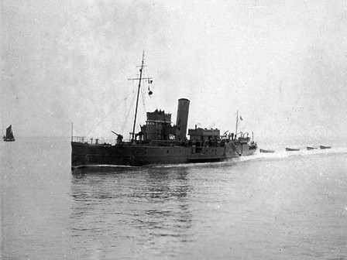
H.M.S. “BARRYFIELD” (i)
4 May 1907 launched by John Brown & Co, Clydebank named BARRY for Barry Railway Co, Cardiff.
29 June 1915 requisitioned for Admiralty service as a Fleet Messenger then a Stores Carrier,
based at Mudros. 1917 renamed HMS BARRYFIELD
20 November 1919 returned to her owners and name reverted to BARRY.

SS CRANMORE
Name | Official number | Flag | IMO
CRANMORE | 120894 | GBR
Year built | Date launched | Date completed
1905 | 11/10/1905 | 11/1905
Vessel type | Vessel description
Cargo | Steel Screw Steamer
Builder |  | Yard | Yard no
Richardson, Duck & Company Ltd., |  |  | 568

Tonnage | Length | Breadth | Depth | Draft
3157 grt / 2010 nrt / | 345.0 ft | 46.0 ft | 24.3 ft
Engine builder | Blair & Co. Ltd., Stockton-on-Tees
Engine detail

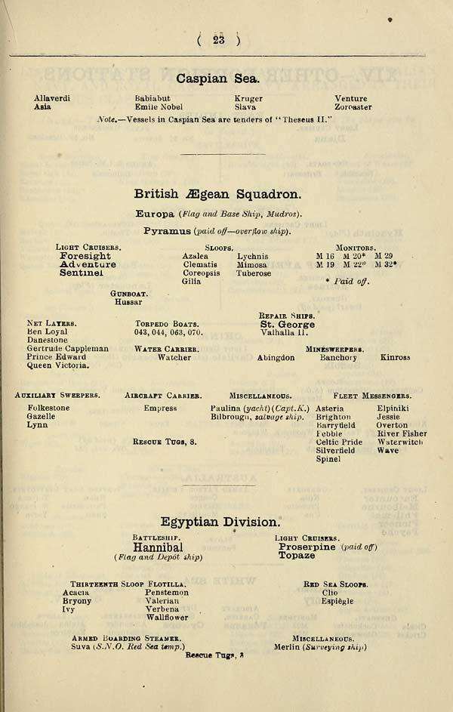
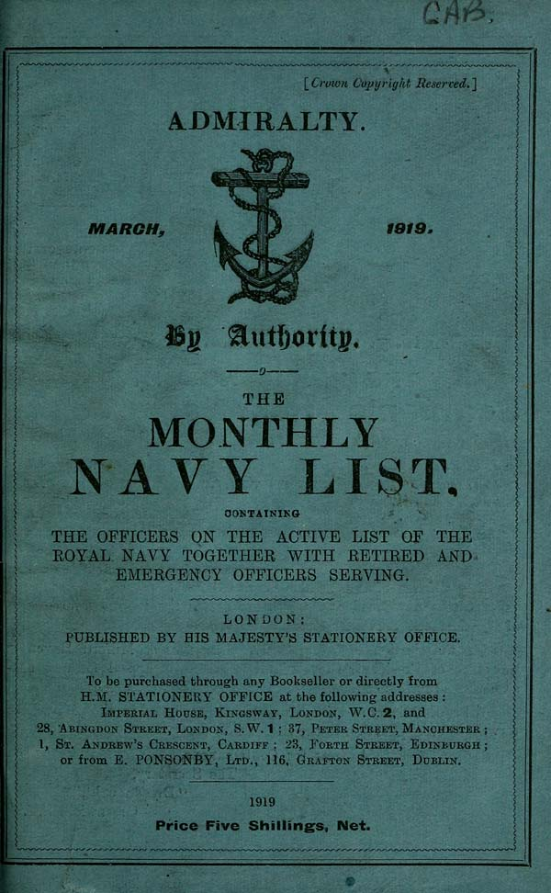

https://www.google.com/url?sa=i&url=https%3A%2F%2Fdigital.nls.uk%2Fbritish-military-lists%2Farchive%2F92420306%3Fmode%3Dtranscription&psig=AOvVaw2-F7Mk1msC298WhF4kUc5i&ust=1650715250476000&source=images&cd=vfe&ved=2ahUKEwjDyqfSz6f3AhUJUBoKHQRxAN8Qr4kDegQIARBf

